Name - Lovepreet kaur

Student id - 2036239

Module - (7CC005)Web Technologies

Module Guide - Alix Bergeret

**SELLING OF PRODUCT FROM THE WAREHOUSE**

**Table of Contents**

Discussion 3

Reference List 9

# Discussion

This part will describe the methods and techniques that are used in the implementations of the software (Dalal *et al*. 2018). The word "web development" refers to the process of envisioning, designing, developing, implementing, and running web applications and application software. The Implementation of web application teaches users web development through a hands-on methodology to the key technologies as well as software programs. The report contains "state-of-the-art" programming languages like HTML, MySQL, PHP, JavaScript, and so on to provide a grasp of the essential areas of web programming in order to achieve the development of a website that is database-driven. The main notion for putting this effort into action is based on two axes (Hedaoo *et al*. 2017). The first is to demonstrate that new XML visual technologies can be used in a web environment while integrating multiple file types and vector graphics images, and the second is to demonstrate that this developed system is simple to implement and provides end-users with effective results of the developed web application (Aniche *et al*. 2019). E-commerce has become very popular in the shopping sector in recent times. Multiple programs can be used as an application for e-commerce. These applications are based on working models and function with various e-commerce models. E- commerce is the online acquisition for the purpose of completing the transaction. The products are sold with the help of e-commerce. It is also called "electronic or web trading". The people will be able to save their valuable time with the help of this e-commerce website. There are several kinds of e-commerce models that are available. These models of business are as follows. "Business to Consumer'' model or "B2C" model, "Business to Business'' model or "B2C" model, "Consumer to Business" model or "C2B'' model, "Consumer to consumer" model or ''C2C". These e-commerce companies require efficient developers for the purpose of fulfilling the requirements of all customers for their software. Along with the implementation and the discussion of the E-commerce web application, testing is also essential and it is also done. Whether there are any errors or any bugs that are occurring in the following software, they can be detected at an early stage and can be cleared up before software product delivery. Testing software in a proper way guarantees the reliability of the following software, safety, and the possibility of high performance that further saves them time, saves money, and satisfies the user of the software. This is the importance of testing software.

The implementation is done effectively with the help of HTML, CSS, and AngularJS and in addition to that MySQL is also used to store the data in the database. HTML is a markup language to create the framework of the website and CSS which stands for cascading style sheets is for styling the website for making it attractive and professional. AngularJS on the other hand extends HTML by adding new attributes. It is appropriate for a single webpage application. AngularJS is a framework of JavaScript and it is being added to the HTML pages of the website. The code has been written in JavaScript. AngularJS has been distributed in the form of a JavaScript file which is added to the webpages using a script tag (Marijan *et al*. 2019).

For the backend, ReactJS has been used. It uses a "virtual DOM" that is a JavaScript object. This is client-side server programming. It is used to manage larger applications. As it is also appropriate for single-page applications, it will be useful in the future if this website is developed as an application. Here an API has been created using ReactJS as ReactJS is a high-level component API. At first, the elements will be created and transformed and it will be fragmented. There are three most crucial methods which are used in the React component API. These are the setState (), force state () and findDOMNode () methods. The database is integrated into the API. The login information, product details, user information will be stored in the database (Alaqail *et al*. 2018).

When any user visits the website or in the web application, then the data or the credentials of the user will be safely stored in the database of the web application.

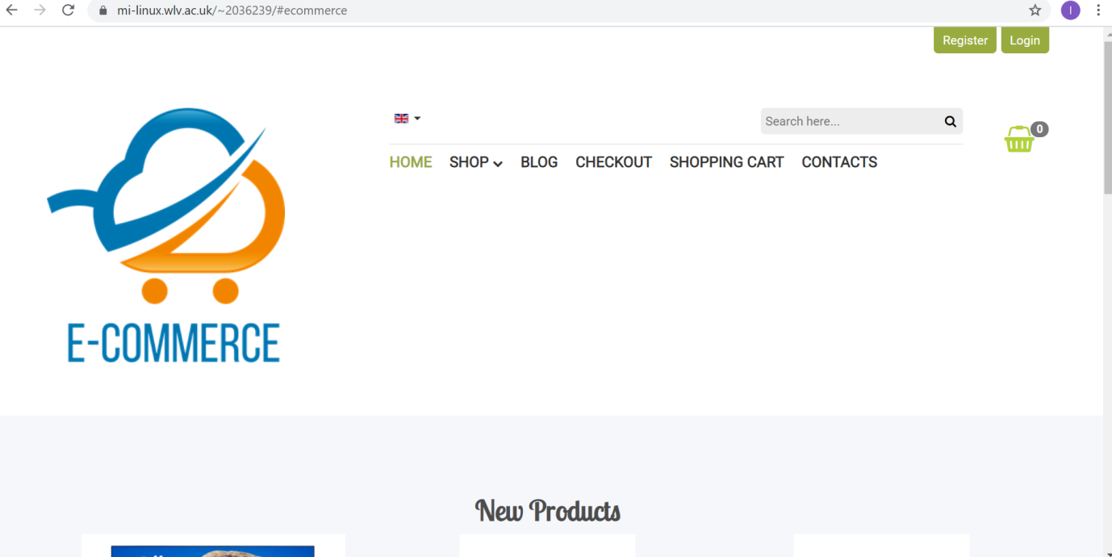

**Figure 1: Home page of E-Commerce**

**(**Source: Self-created**)**

This is the main page or the homepage of the following website, where the user will enter first. This is an e-commerce website. HTML will be used for the purpose of displaying the homepage of the following website (Lachmann, 2018). For web design, HTML is used. The heading of the homepage is written with the help of HTML on the homepage of the software. The homepage of the following software is displayed in a card-view. These cards have been created using HTML. The process of component creation for the pages is done with the help of HTML. "AngularJS" is used for the purpose of adding the functionality of the components of the homepage. JAVASCRIPT is a programming language that confirms the ECMAScript’s specification. It is a language of a very high level, which can be compiled in time. It is an "object-oriented programming" prototype (Rani *et al*. 2020). There are a lot of components on the main page of the website such as the search bar, welcome note, login, register, etc. all of these components are designed with the help of "Angular JS" which is a form of "JavaScript". It is used to generate the functionality of the created components. All the colouring of the homepage is done with the help of CSS or a "cascading style sheet". CSS or the “cascading style sheet" is a special type of "style sheet language" which is used for the purpose of designing some of the documents that are written in the HTML and AngularJS versions (Sugali *et al*. 2021). It is used for the design of the website that is created. It is used for the purpose of creating any animation of the page. The process of colouring is done with the help of CSS.

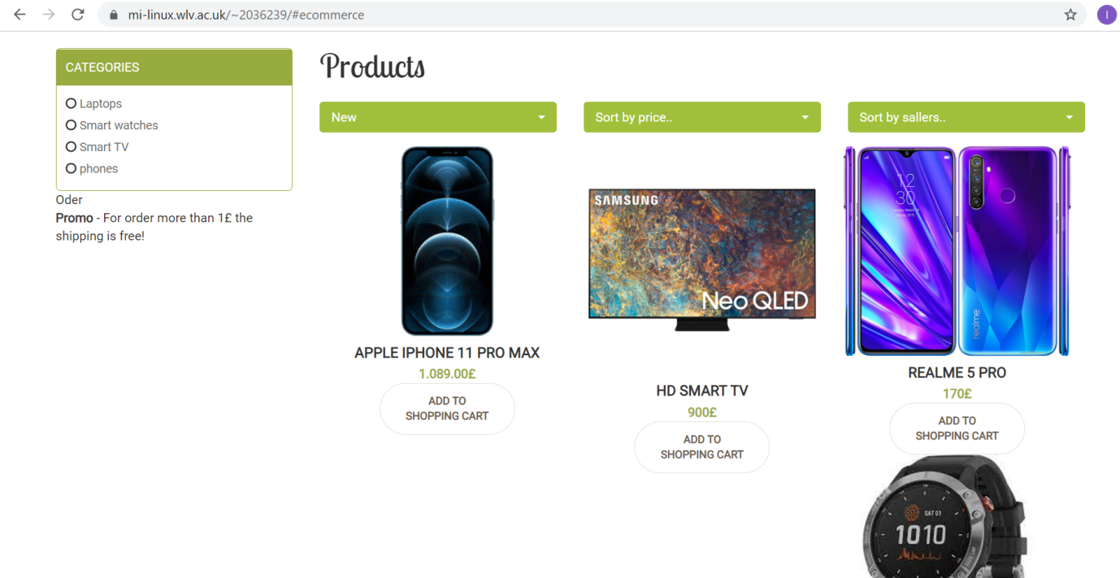

**Figure 2: Products page of Ecommerce**

**(**Source: Self-created**)**

The next page is the list of products. On this page, all the products are shown with their details and with an image of every product. This page is also created with a card view model. The price of every product is shown with the picture of every product. HTML is used to design this page. All the cards of this page are created with the help of HTML (Bhatt, 2017). "AngularJS" which is a framework of JavaScript is used for the purpose of generating the functionality of this following page. All the colours of this following page are filled with the help of CSS. The animations are done with CSS also. It is used for the purpose of designing the page.

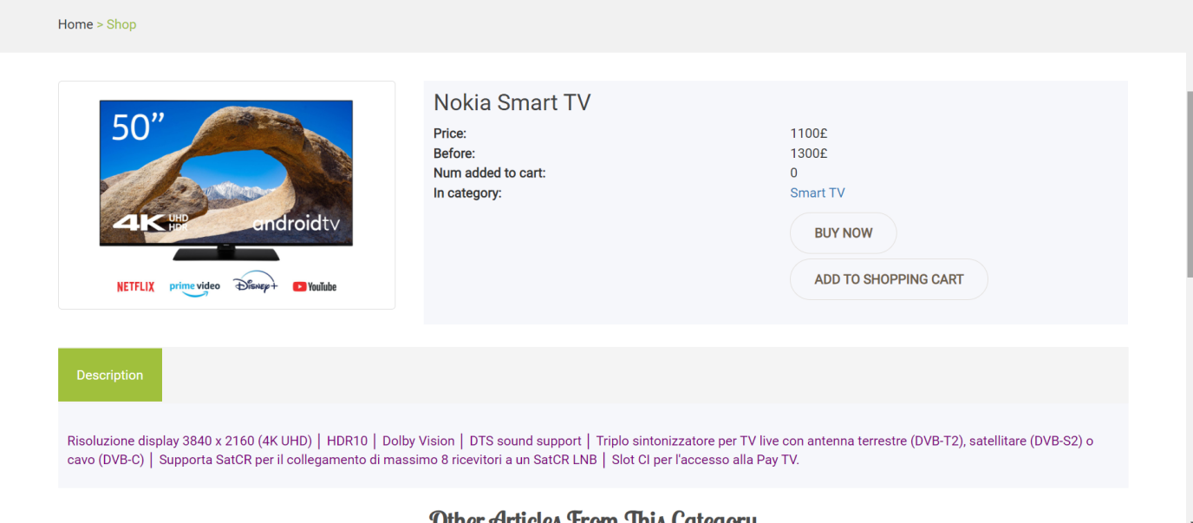

**Figure 3: Product details page of Ecommerce**

**(**Source: Self-created**)**

The next page that is being displayed is the product details page. After selecting any product from the product list page, this page appears for any particular selected item. When a particular item is chosen by the user to get a description and full details of the product, this particular page helps the user to gain knowledge regarding the selected item. On this page, it is seen that the various images of the product are there from various angles (Taley *et al*. 2020). The price of the product is also given along with the currency symbol. Under the price of the product, there is a brief description of the product presentation and under that, there is an option o0f "Add to cart". When the user or the customer will press on "Add to cart", the user will be redirected to the purchase page. According to the selected product, there are also related products displayed below.

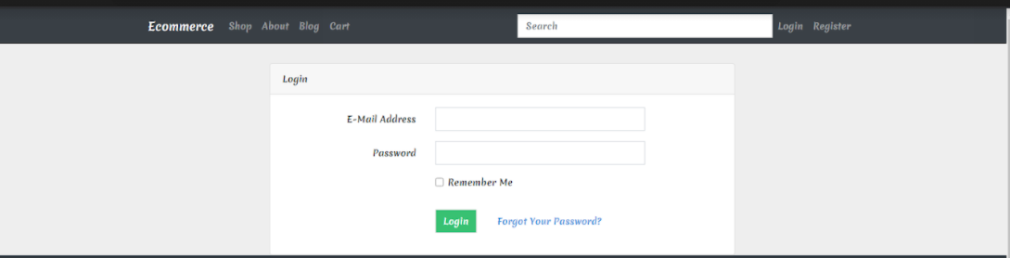

**Figure 4: Login page of Ecommerce**

**(**Source: Self-created**)**

The above figure represents the login page of the website. If the user already registered on the website and has an account, then the user will log in to the website to access his account. The user will have to enter his login credentials such as the user's registered email address and password. While login the registered information from the database will be matched with the entered login credentials and if it matched properly then the login will be successful otherwise it will show an invalid email address or password. If the user forgot his password, then he can reset his password by clicking on the "Forgot Your Password?" link. The link will direct to the page where the user will be asked for his registered email address and a verification code for verification and the verification code will be sent to that email address. The user will have to enter that code to validate that he is the authorized user. Then the user will be asked to enter his new password and confirm the new password. In the next step, the password will be changed. Then the user can proceed to log in again. The user also can click on the "Remember me" checkbox to save his login credentials for future login (Valle *et al*. 2017).

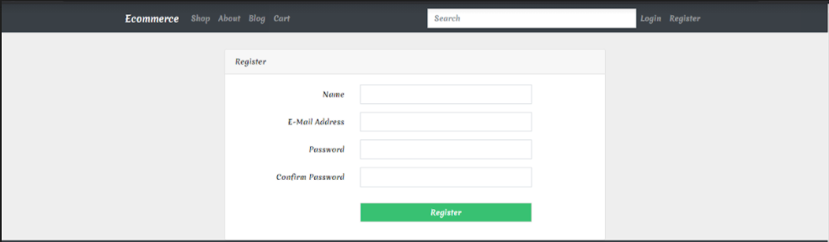

**Figure 5: Registration page**

**(**Source: Self-created**)**

The above figure represents the registration page of the website. If the user is new to the website and has not registered his account yet, then the user will have to go to the registration page. First, after entering the website, the user can check the website features and products first without being registered. After the user decides to buy a product from the website then he has to register an account for purchasing. On the registration page, the user will have to enter his name, email address, password and confirm the password. Then after clicking on the register button, the information will be stored in the database. This information will be fetched at the time of login. The webpage is styled with HTML and CSS. The input textboxes are created using input tag and the labels are created using label tag. The button is created using the button tag. Inside the button tag "onclick" function has been used to fetch the inputs from the textbox. The website is very user-friendly (Chaudhary, 2017).

The Internet swept the globe by storm, and so as a consequence, it grew quickly in a variety of areas. Many features of its initial stages, including its aesthetic and desktop orientation, are still visible. However, the Website is still evolving at a quick pace: there are already more users on smartphones than on desktop computers, and there is a wide range of device kinds, screen kinds and configurations, and screen resolutions. Dealing with this diversification is difficult to reach simply by keeping a list of potential devices and creating multiple websites for each of them because the complexity would be impossible to manage, and since once sites began rejecting browsers and technologies as they didn't recognize and the major browsers decided to respond by concealing themselves. There is also the variety necessary for accessibility on the upper edge of all this. Although enabling access for visual impairments is a crucial reason for accessibility, humans are all legally blind to some degree at some point in their lives. In contrast to somebody sitting behind one screen, while showing an application on a projection screen at a meeting, the whole listener will often be legally blind. The emergence of different "Ten-foot Interfaces" shows that the original programs were not created with accessibility in mind. Because of the Web's success, the browser has become the user's principal enabling technology, and one may spend the majority of the day using it to interact with apps, read mail, shop, and search their disk drive. The introduction of web-based apps such as "Google Maps" and "Gmail" has shifted attention to web-based application delivery, not least as it solves versioning issues. The most current edition of the program is always available to everyone. One could only anticipate seeing even more Web-based apps throughout the future because they serve both the provider and the user.

# Reference List

**Journal**

Alaqail, H. and Ahmed, S., 2018. Overview of software testing standard ISO/IEC/IEEE 29119. International Journal of Computer Science and Network Security (IJCSNS), 18(2), pp.112-116.

Bhatt, D., 2017. A survey of effective and efficient software testing technique and analysis. Iconic Research and Engineering Journals (IREJOURNALS), 326.

Chaudhary, S., 2017. Latest Software Testing Tools and Techniques: A Review. International Journal, 7(5).

Dalal, S. and Hooda, S., 2018. ASPECT-ORIENTED SOFTWARE TESTING TECHNIQUES: A REVIEW. International Journal of Advanced Research in Computer Science, 9(2).

Hedaoo, A.H. and Khandelwal, A., 2017. Study of Dynamic Testing Techniques. International Journal, 7(4).

Rani, S. and Gupta, D., A Comparative Study of Different Software Testing Techniques: A Review.

Sugali, K., Sprunger, C. and Venkata, N.I., 2021. SOFTWARE TESTING: ISSUES AND CHALLENGES OF A RTIFICIAL INTELLIGENCE & MACHINE L EARNING. International Journal of Artificial Intelligence and Applications (IJAIA), 12(1).

Taley, M.D.S. and Pathak, B., Comprehensive Study of Software Testing Techniques and Strategies: A Review.

Valle, P.H.D., Toda, A.M., Barbosa, E.F. and Maldonado, J.C., 2017, October. Educational games: A contribution to software testing education. In 2017 IEEE Frontiers in education Conference (FIE) (pp. 1-8). IEEE.

Lachmann, R., 2018, June. Machine learning-driven test case prioritization approaches for black-box software testing. In The European Test and Telemetry Conference, Nuremberg, Germany.

Aniche, M., Hermans, F. and Van Deursen, A., 2019, February. Pragmatic software testing education. In Proceedings of the 50th ACM Technical Symposium on Computer Science Education (pp. 414-420).

Marijan, D., Gotlieb, A. and Ahuja, M.K., 2019, April. Challenges of testing machine learning based systems. In 2019 IEEE International Conference on Artificial Intelligence Testing (AITest) (pp. 101-102). IEEE.